# Program 1

//a program to depict the function overloading concept

#include<iostream> using namespace std; float area(float r)

{

return (3.141)*r*r;

}

int area(int a,int b)

{

return a*b;

}

int area(int s)

{

return s*s;

}

int main()

{

float r,ac;

int a,b,s,ar,as;

cout<<"\nenter the radius of circle : ";

cin>>r; ac=area(r);

cout<<"\nenter the length and breadth of rectangle : "; cin>>a>>b;

ar=area(a,b);

cout<<"\nenter the side of the square : "; cin>>s;

as=area(s);

cout<<"\narea of the circle is : "<<ac; cout<<"\narea of the rectangle is : "<<ar; cout<<"\narea of the sqaure is : "<<as;

return 0;

}

Output:-

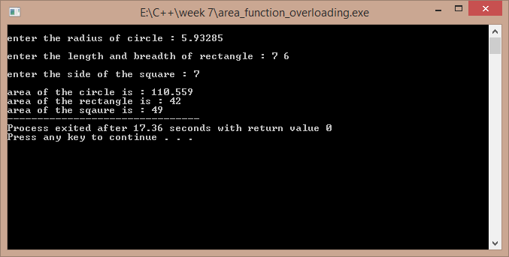

# Program 2

//a program to add complex numbers using operator overloading

#include<iostream> using namespace std; class complex1

{

float real,imag; public:

complex1()

{

real=imag=0;

}

complex1(float a,float b)

{

real=a; imag=b;

}

void display();

complex1 operator +(complex1 m);

};

void complex1::display()

{

cout<<"\n"<<real<<" + "<<imag<<"i"<<endl;

}

complex1 complex1::operator +(complex1 m)

{

complex1 temp; temp.real=this->real+m.real;

temp.imag=this->imag+m.imag; return temp;

}

int main()

{

complex1 a,b; float p,q,r,s;

cout<<"\nenter the real and imaginery part of first complex number : "; cin>>p>>q;

cout<<"\nenter the real and imaginery part of second complex number : ";

cin>>r>>s; a=complex1(p,q); b=complex1(r,s); complex1 c; c=a+b;

cout<<"\nthe addition complex number is : "; c.display();

return 0;

}

Output:-

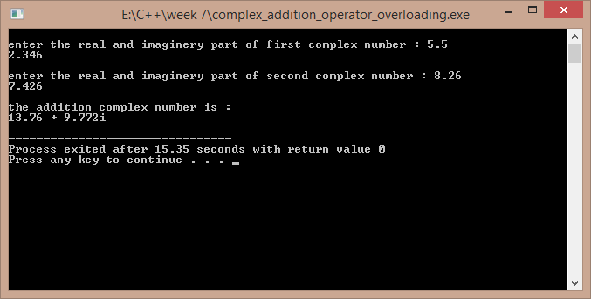

# Program 3

//a program to overload the operator regarding the strings

#include<iostream>

#include<cstring> using namespace std; class str

{

char *s; int l; public:

str()

{

l=0;

s=new char[l+1];

}

str(char *p)

{

l=strlen(p); s=new char[l+1]; strcpy(s,p);

}

str(int k)

{

l=k;

s=new char[l+1];

}

str operator +(str);

int operator <(str); int operator >(str); void operator =(str); int operator !=(str); void display()

{

// cout<<this->l; cout<<"\n"<<this->s;

}

};

str str::operator +(str a)

{

str t;

t=str(strlen(this->s)+strlen(a.s)); strcpy(t.s,this->s);

strcat(t.s,a.s); return t;

}

int str::operator >(str a)

{

if(strcmp(this->s,a.s)>0) return 1;

else return 0;

}

int str::operator <(str a)

{

if(strcmp(this->s,a.s)<0) return 1;

else return 0;

}

void str::operator =(str a)

{

strcpy(this->s,a.s);

}

int str::operator !=(str a)

{

if(strcmp(this->s,a.s)!=0) return 1;

else return 0;

}

int main()

{

str x,y;

char temp[100];

cout<<"\nenter the first word : "; cin>>temp;

x=str(temp);

cout<<"\nenter the second word : "; cin>>temp;

y=str(temp); str xy; xy=x+y;

cout<<"\nthe joint of the words is : "; xy.display();

cout<<"\nhere x is the first word and y is the second word ."; cout<<"\nthe result of x>y is : "<<(x>y);

cout<<"\nthe result of x<y is : "<<(x<y); cout<<"\nthe result of x!=y is : "<<(x!=y); return 1;

}

Output :-

